**Superset ID :**  6365405

**Design Patterns and Principles**

**Exercise 1: Implementing the Singleton Pattern**

Logger.cs

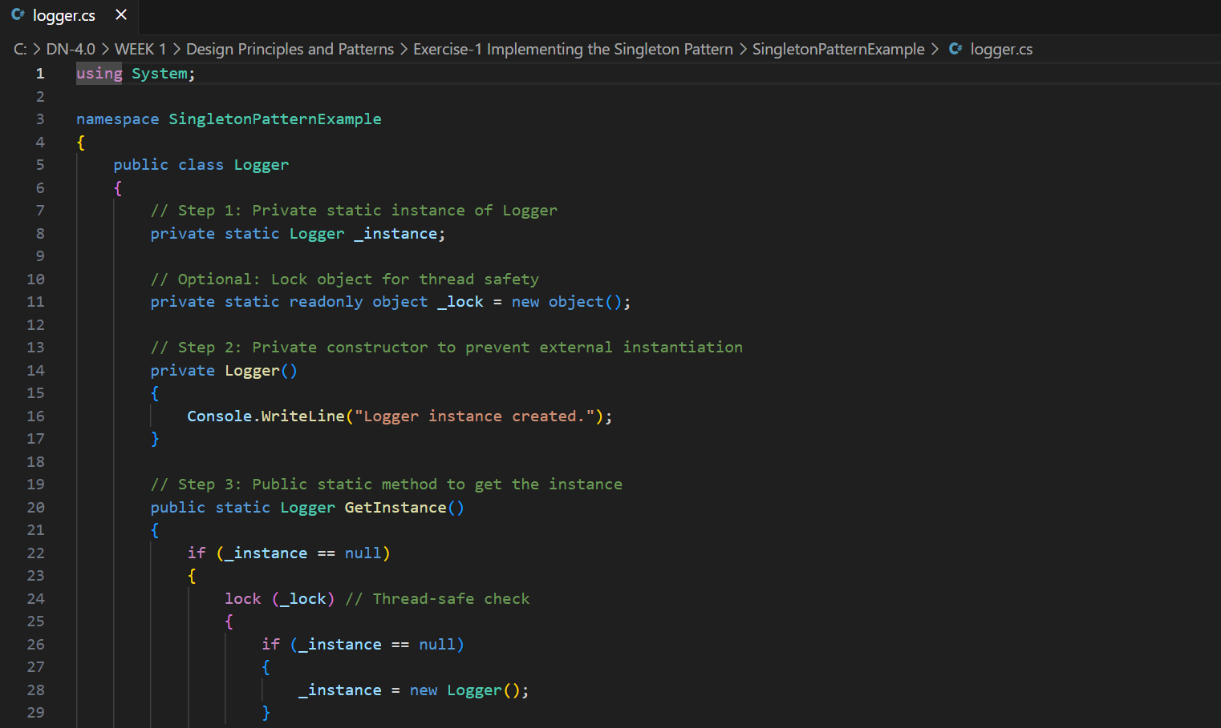

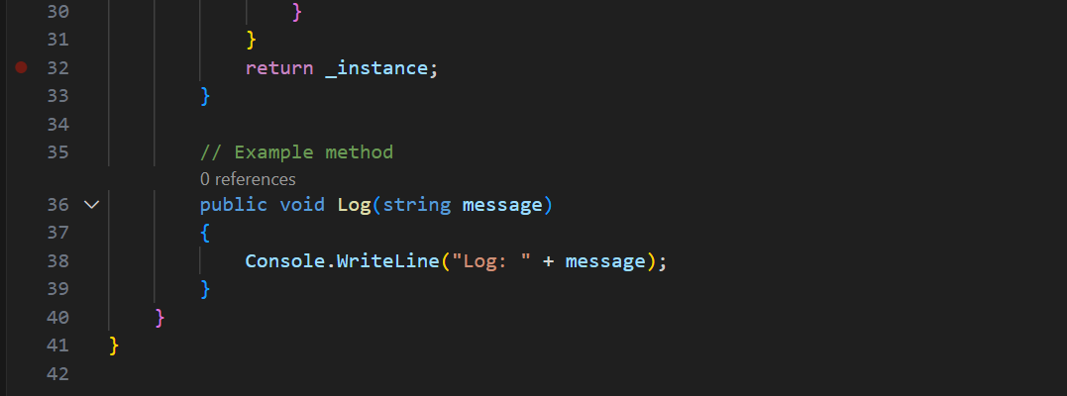

Program.cs

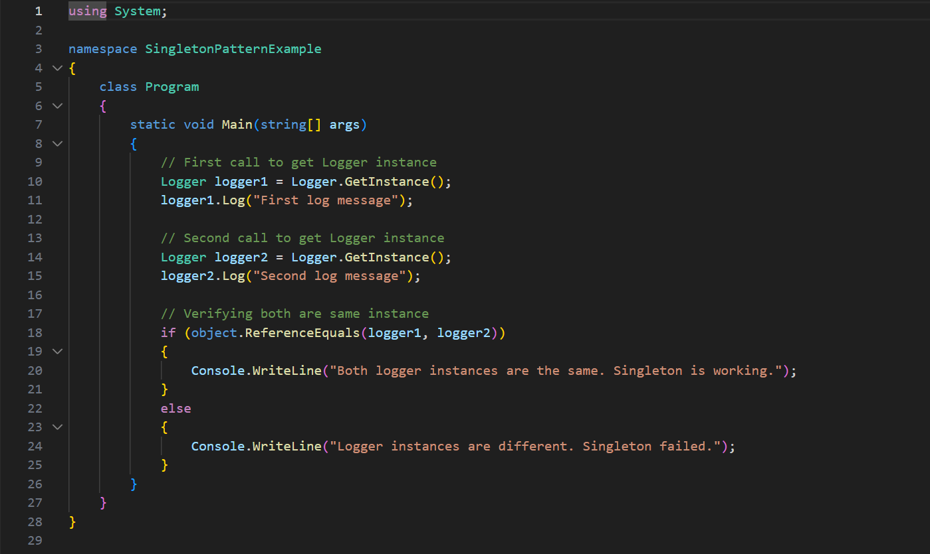

Output : 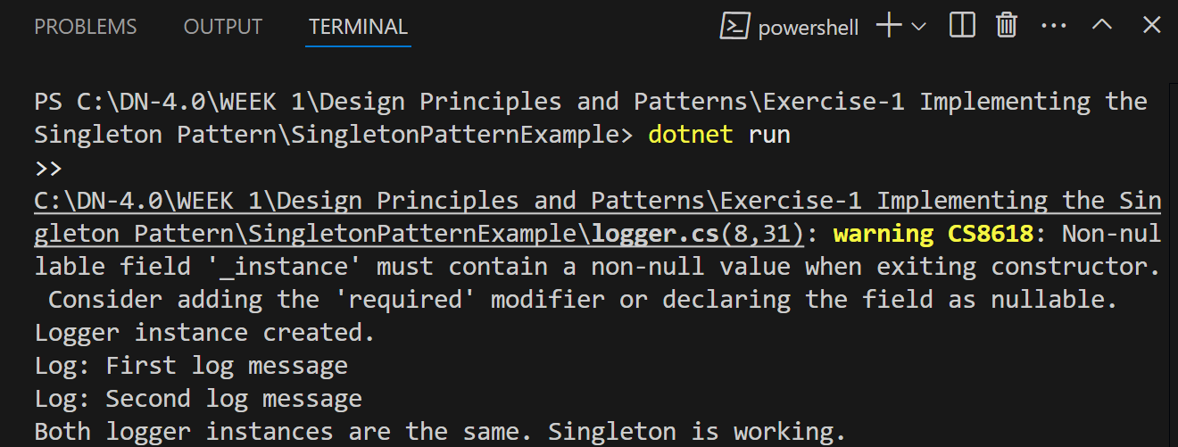

**Exercise 2: Implementing the Factory Method Pattern**

ExcelFactory.cs

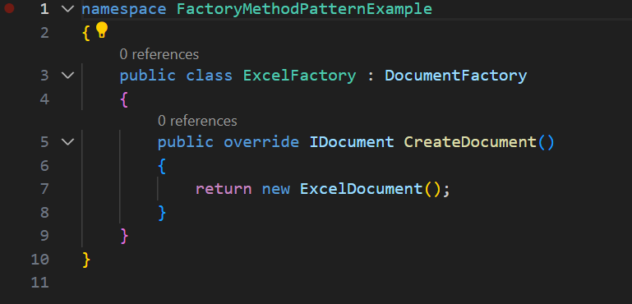

PdfFactory.cs

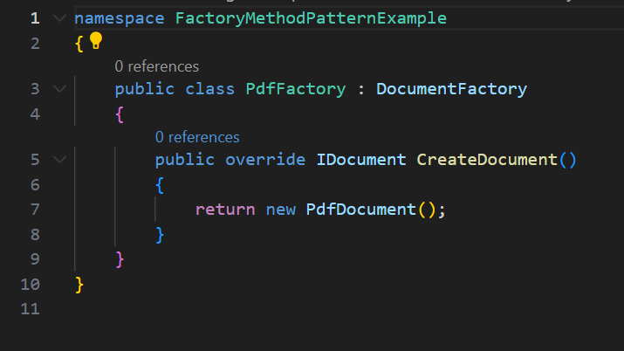

WordFactory.cs

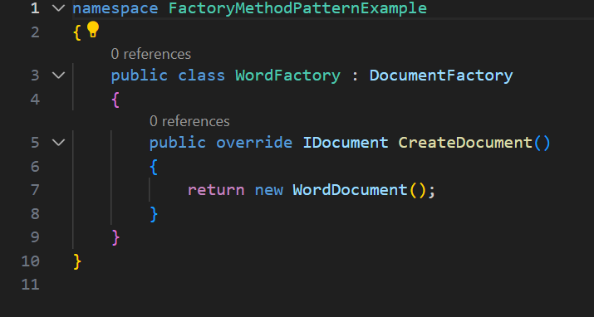

ExcelDocument.cs

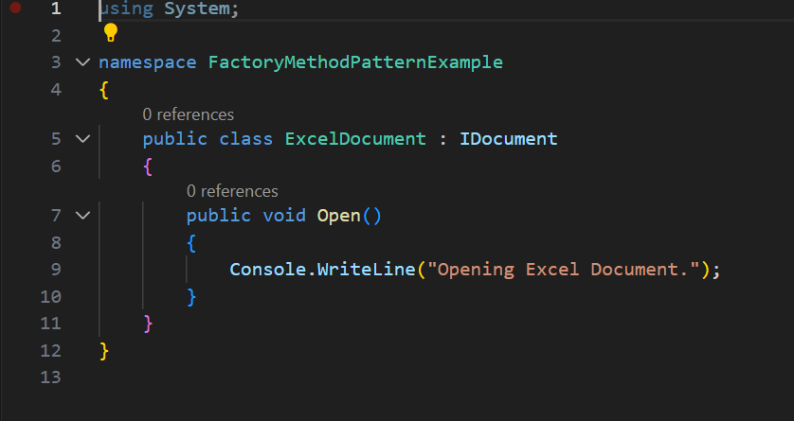

PdfDocument.cs

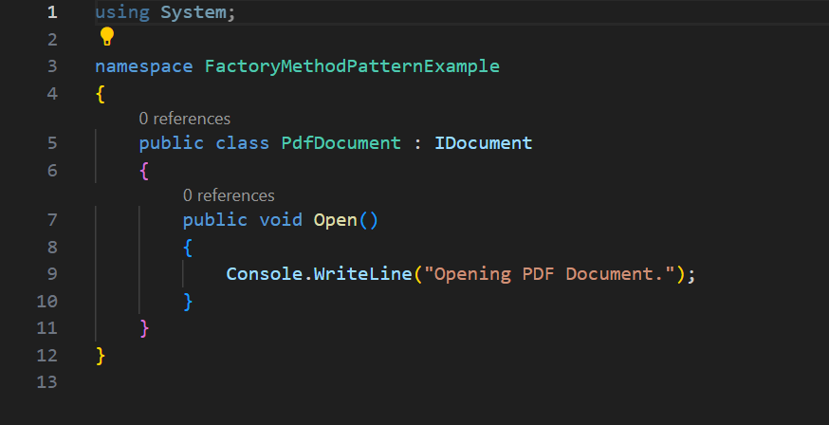

WordDocument.cs

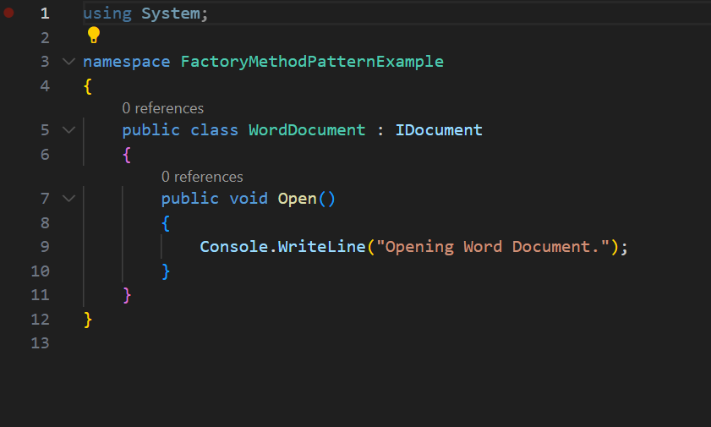

IDocument.cs

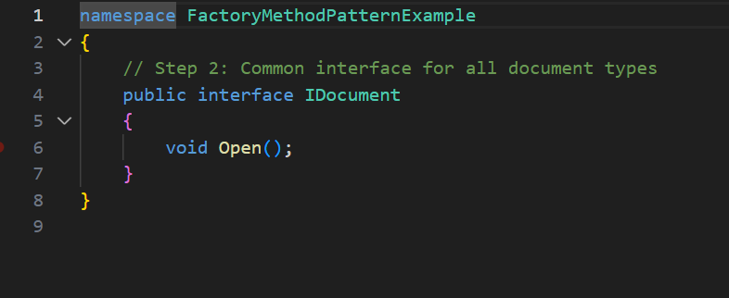

Program.cs

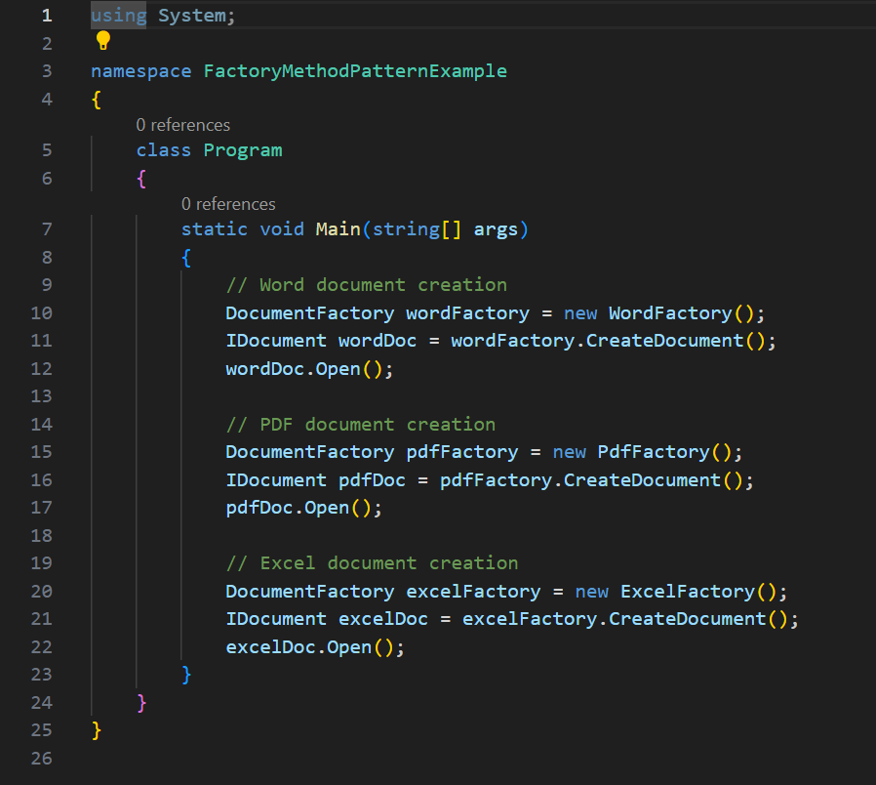

**OUTPUT :**

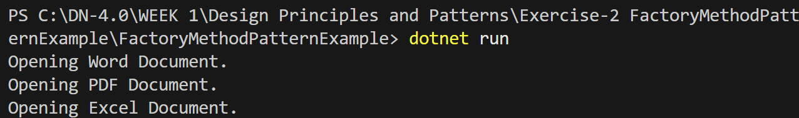

********************THANKYOU************************